“Chinese Bridge” online
Hebei Normal University

As a way of fighting the pandemic and with the approval of the Center for Language Education and Cooperation, formerly known as Hanban, Hebei Normal University is launching the “Chinese Bridge” Online Group Project to avail foreign Chinese learners the opportunity to continue learning Chinese online. Below is the project scheme:

- Eligibility
- Citizens of Brazil and Peru
- In good health condition and possess good character
- Have basic knowledge of Chinese and love Chinese culture

- Introduction
This project is a one week project solely aimed at Brazilian and Peruvian students. 7 days of concentrated Chinese language training would not only improve student’s language proficiency but also increase their understanding of Chinese culture and contemporary development features.
- Course Type
- Online Course: Students are to attend the online live class 8 am Beijing time every morning, 9 p.m at Brazil Time and 7 p.m at Peru Time.
- Video Course: Students can watch the recorded videos at their convenience.
- Course Introduction: The course is divided into 7 topics, laying more emphasis on Language learning, with culture introduction.
- Course Time: January 14 to 22, 2021. Students rest on the 16th and 17th.

- Learning Mode
Learning will take place online.

- Course Completion
At the end of the course, students will make a video to share their learning experience and fill a feedback questionnaire. After which they will get a completion certificate.

- Registration
Register with local teachers in charge of the project, fill the registration form(see attachment1 below), and create a “Chinese Bridge” student account following the instructions in attacment2 below.

- Deadline
Registration Deadline is December 30, 2020.

- Contact
Contact person: Rosemary
Phone number: 86-0311-80789542
Email: scholarship@hebtu.edu.cn

Attachment 1 Registration form
HEBEI NORMAL UNIVERSITY - BRAZIL AND PERU GROUP PROJECT REGISTRATION FORM
S/N | Email registered on “Chinese Bridge” website | Chinese Name | Passport Name | Date of Birth | Age | Gender | Nationality | Passport number or ID number | Are you a Confucius Institute’s student?  （Fill Yes/No） | Chinese proficiency level  (HSK)

Attachment 2 Application process on“Chinese Bridge”website
- Log on to Hebei Normal University “Chinese Bridge” Brazil/Peru Exchange Online Group Project.
http://bridge.chinese.cn/online/camp/camp/1100/accounts/blinding/10039

- Select “create a new account”, as shown in the picture below：
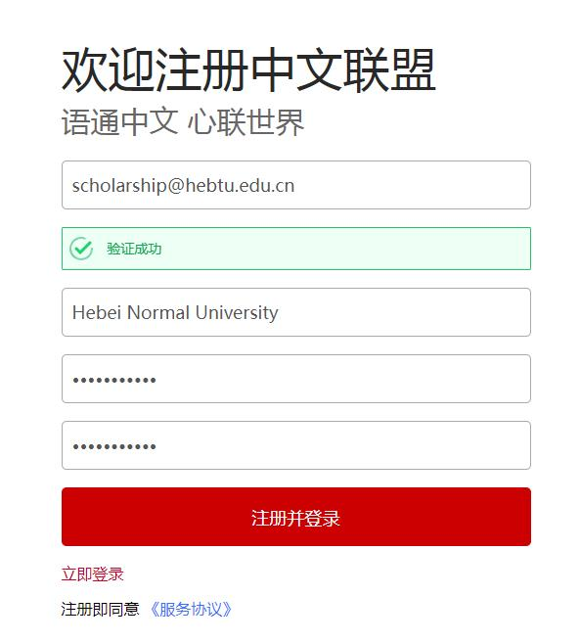

- Fill in registration information
