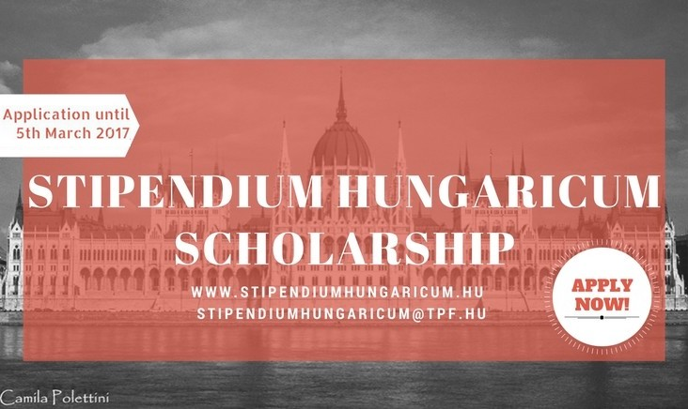

Stipendium Hungaricum scholarship programme – Hungary

We are very glad to inform you that the Stipendium Hungaricum scholarship programme is now available for Brazilian students and researchers for undergraduate, graduate and doctoral studies in all scientific fields!

The core mission of the programme – launched by the Hungarian Government – is to increase the number of foreign students in Hungary and to encourage Hungarian higher education institutions to attract top foreign students.

More information on the programme can be found at www.stipendiumhungaricum.hu and the details of the call are available here: http://www.tka.hu/docs/palyazatok/20170119_call_for_applications_2017_20181701191427.pdf

In case of any questions regarding the program, please contact the SH coordinators via skype ”stipendiumhungaricum” or via email: stipendiumhungaricum@tpf.hu.

The online application system can be found here: https://cwp.scholarship.hu/
Application deadline: 5 March 2017

Get prepared and check out the video interviews with international students to learn about the benefits of studying in Hungary: https://www.youtube.com/watch?v=VZUf4h3lJJE&spfreload=10

Facebook event: https://www.facebook.com/events/1305881912806920/

Good luck for all the future SH applicants!

